**Optimization and Active Stabilization of a Far-Infrared Laser for NSTX-U High Poloidal WavenumberScattering Diagnostics**

**Abstract**

The far-infrared (FIR) laser output beam power and pattern are critical parameters in laser-aided diagnostics, directly influencing the spatial resolution and signal-to-noise ratio of measurements. This work focuses on developing a systematic control method to enhance FIR laser beam quality through optimized mirror alignment and real-time feedback-based precision cavity length tuning. A high-power CO₂ laser, aligned with the waveguide axis using a HeNe reference laser, serves as the pump source. The sensitivity of FIR beam intensity to pump gas pressure and thermal expansion is investigated, revealing that even a 1 μm cavity expansion can significantly degrade output power stability. To address this, a feedback control module has been designed and implemented for active cavity length adjustment, stabilizing the output power at approximately 30 mW. Additionally, maintaining a high formic acid gas pressure (>190 mTorr) within the cavity ensures reliable operation. The optimized FIR laser will be deployed on the NSTX-U high poloidal wavenumber scattering system for studying electron-scale turbulence in tokamak plasmas.

**Section I: Introduction**

Transport is one of the key research topics in fusion plasma physics. In experiments conducted on the NSTX device, electron-scale transport has been observed to exceed neoclassical transport predictions by a significant margin [ref]. This elevated transport can lead to substantial particle and thermal losses, ultimately degrading plasma confinement. Consequently, understanding and controlling electron dynamics is critical for the successful operation of tokamaks. The NSTX-U device, with its distinctive high-beta and low-collisionality conditions, provides an ideal platform for investigating electron-scale turbulence. This study will systematically explore how turbulence characteristics vary with essential parameters such as collisionality, the q-profile, and E×B shear, aiming to identify the mechanisms that govern confinement scaling. An essential diagnostics system in this investigation is the 693 GHz, 8-channel millimeter-wave poloidal scattering system, which will measure electron-scale turbulence across the plasma core to edge (normalized radius from 0.2 to 1) with a poloidal wavenumber range of 7 to ~40 cm−1. This capability enables comprehensive coverage of the predicted electron temperature gradient (ETG) and other electron-scale turbulence spectra.

The system utilizes an optically pumped far-infrared (FIR) laser with formic acid (HCOOH) vapor serving as the gain medium. It is pumped by a 150 W CO₂ laser operating at the 9R20 line (9.27 μm), which drives rotational transitions to generate the 693 GHz FIR signal. The output beam is coupled into a waveguide and directed to the launch optics, where adjustable mirrors allow precise beam steering for various measurement configurations. Maintaining a high-quality Gaussian beam profile is critical for efficient waveguide coupling. This depends sensitively on the precise alignment of FIR cavity components, including perforated copper mirrors, mesh grids, and dielectric wafers. Even minor misalignments (as small as 0.1°) can significantly degrade the output beam quality. Additionally, heat from the CO₂ laser can alter the length of the FIR laser cavity, resulting in a drop in output power. This work addresses these challenges by developing a repeatable alignment methodology and identifying the key factors that govern beam pattern and power optimization in FIR systems.

This paper focuses on optimizing the performance of a 693 GHz far-infrared (FIR) laser through precision optics alignment and cavity length feedback control. The system is driven by a CO₂ pump laser, and its output beam quality is important for high poloidal wavenumber scattering diagnostics. Section 2 reviews the FIR laser setup, while Section 3 presents beam pattern optimization by optics alignment. Section 4 details power stabilization through real-time cavity length feedback control and gas pressure tuning. Finally, Section 5 summarizes the implications for improving FIR laser stability and output efficiency.

**Section II: FIR laser setup and beam quality importance**

1. **FIR laser and CO2 laser system overview**
2. **FIR beam output beam power and pattern distortion affected on scattering system (diagnostics degradation)**
3. **NSTX-U FIR laser requirement**

**Section III: Beam pattern optimization by optics alignment**

1. **Principle of laser optics setup**
2. **Non-ideal beam pattern sample**
3. **Alignment process and beam pattern quality improvement**
4. **Please add a short description about the regular alignment duration requirement**

**Section IV: Beam power stabilization**

1. **Beam power decreasing with nature operation (no feedback control)**
2. **Key parameters (beam power): cavity length, gas pressure**
3. **Beam power performance with feedback control module**
4. **Please add a short description about the regular adjustment duration requirement**

**Section V: Summary**

1. **One sentence about high k scattering laser requirement**
2. **Three sentences about optimized beam power and pattern performance**
3. **Summarize the optics alignment method, cavity length adjustment method, and more.**
4. **Impacts on other laser-aided diagnostics.**

**Section II: FIR laser setup and beam quality importance**

1. **FIR laser and CO2 laser system overview**

The CO2 laser system and FIR laser system are working as a whole laser system to produce coherent laser at 693 GHz. The CO₂ laser serves as the pump source, providing high-power, linearly polarized radiation at a wavelength of 9.27 μm. This radiation is directed into the FIR laser cavity, which contains formic acid gas as the gain medium. The FIR laser operates based on molecular rotational transitions, generating radiation in the submillimeter range (around 432 μm), corresponding to the far-infrared region.

1.1 Overview of CO2 laser

The CO₂ laser schematic shown in Fig. 1 features two independent waveguide cavities, each powered by a dedicated high-voltage supply (-15 kV cathode, 0 V anode) that initiates gas breakdown in the CO₂-N₂-He mixture (6:18:76 ratio). This discharge sustains a 40 mA plasma current that excites CO₂ molecules, producing infrared radiation through quantum cascade transitions. The system employs Brewster windows to enforce P-polarization (100% transmission) while suppressing S-polarization through reflection and absorption. Wavelength selection is achieved via a tunable diffraction grating, which together with the output coupler's ZnSe mirror (60% reflectivity at 10 μm) forms the complete laser cavity. Resonant feedback between these components stimulates continuous laser action, with maximum output occurring when the cavity length satisfies the standing wave condition. Fine adjustment of this critical length (up to 15 μm precision) is accomplished through a piezoelectric crystal stack in the output coupler, controlled by 1500 V DC bias (max.).

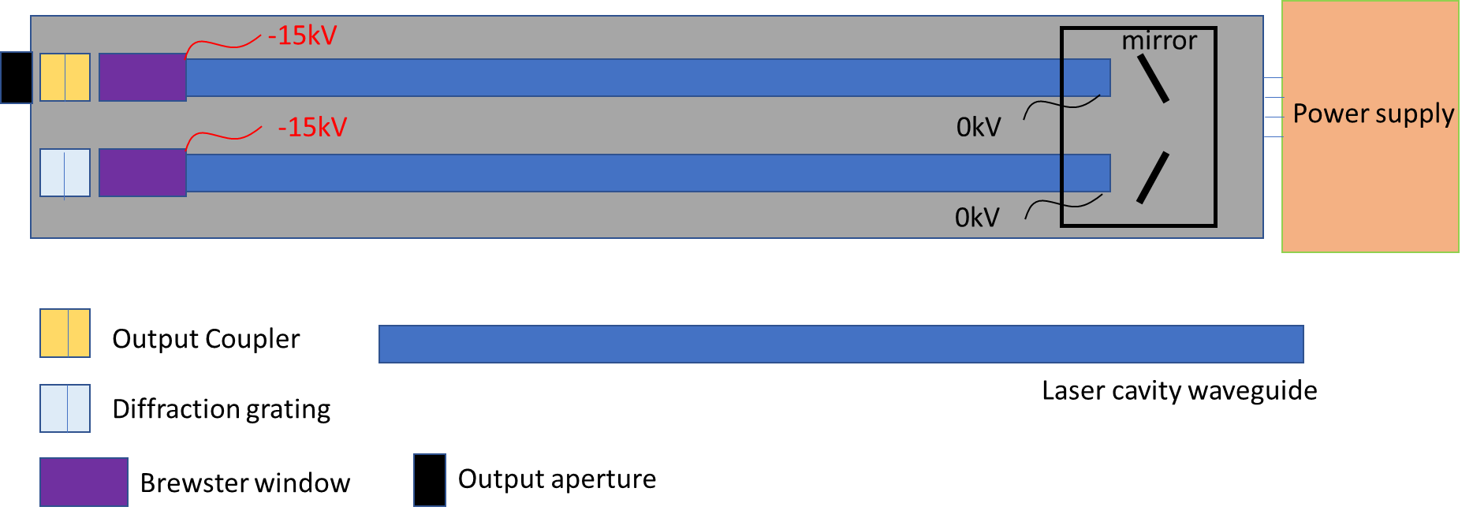

Figure 1. Schematic of the CO₂ laser. The main components include the output coupler, Brewster windows, diffraction grating, and laser cavity waveguide.

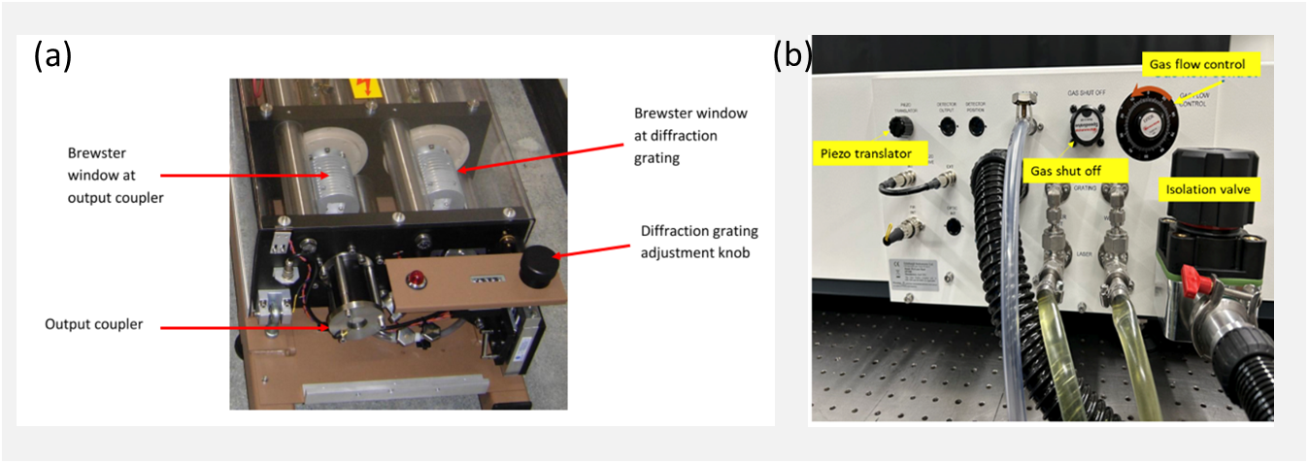

Figure 2. The CO2 laser system control system

To ensure consistent laser performance and wavelength control, a comprehensive optical and electronic infrastructure is integrated into the system. This includes both the resonant optics and the centralized control interface, which facilitate precise tuning and real-time diagnostics. The control systems of the PL-6 CO₂ laser are shown in Fig. 2 (b). The precise wavelength adjustment is achieved through a mechanical knob with indexed counter readout as shown in Fig. 2 (a). The main control panel (Fig. 2 (b)) integrates all critical subsystems: (1) laser cavity optimization via piezoelectric length adjustment, (2) gas handling with flow control and vacuum systems (Figs. 2 (b)), including real-time pressure monitoring, and (3) thermal management through liquid cooling ports. Power is supplied by dual high-voltage sources (15 kV, 40 mA each), enabling stable operation of the complete laser system.

1.2 Overview of FIRlaser

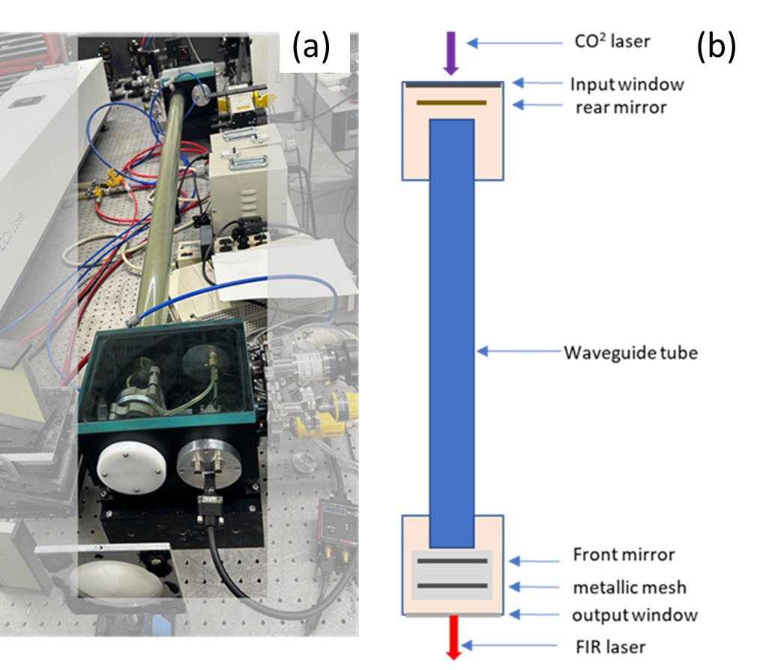

Figure 3. Schematic of FIR laser

The schematic of the FIR system is shown in Fig. 3. The system consists of a rear mirror, a dielectric waveguide tube, a front mirror, and a metallic mesh. The rear mirror is a copper mirror coated with gold, featuring a central hole to allow the CO₂ laser to pass through. The front mirror is a dielectric-coated silicon wafer, designed to provide high FIR transmission (98%) and high CO₂ laser reflection (99%). The metallic mesh has a density of 300 lines per inch (lpi), with 20% transmission and 80% reflection for FIR radiation at a 432 μm wavelength.

The front mirror and metallic mesh are mounted on a stage that can be adjusted along the waveguide axis, driven by a stepper motor. The CO₂ laser oscillates between the front and rear mirrors, while the FIR laser oscillates between the metallic mesh and the rear mirror. By adjusting the cavity length between the metallic mesh and the rear mirror, the output power can be optimized to its maximum value. The output window of the FIR laser system is made of HDPE with plano surfaces, as a concave surface would distort the beam profile.

* 1. The feed-in optical system between CO2 pump laser and FIR laser

A schematic diagram of the feed-in system, as shown in Fig. 4, illustrates the optical path and key components, including mirrors, focus lens, beam splitter, and power detectors. Two reflective mirrors are used to adjust the propagation direction of the CO₂ laser into the FIR laser input coupler window. A focusing lens with a 1 m focal length is used to collimate the CO₂ laser. Behind the input coupler window, a copper mirror with a 4 mm radius central hole is installed. The CO₂ laser is focused such that its beam waist is near the mirror aperture, allowing the beam to expand inside the FIR laser. This configuration reduces the amount of CO₂ laser power that can escape back through the input coupler and potentially disrupt the CO₂ laser operation. The beam splitter diverts 5% of the CO₂ laser power to a power monitor for real-time monitoring.

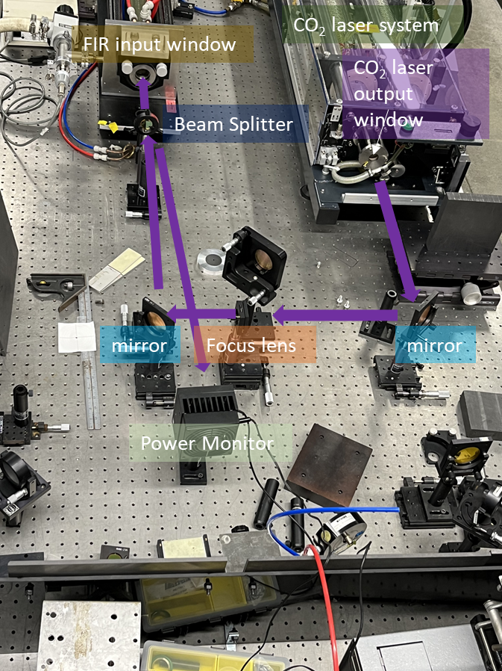

Figure 4. Optical components between CO2 laser and FIR laser.

1. **FIR beam output beam power and pattern distortion affected on scattering system (diagnostics degradation)**

For the High-k scattering system, the laser system is located far from the NSTX-U device, making a waveguide necessary to minimize transmission losses between the laser and the tokamak. The FIR beam profile is critical for achieving high coupling efficiency with the waveguide, designing the launch optics, and ensuring accurate diagnostic spatial resolution. Only a Gaussian beam profile can provide high coupling efficiency and enable standard optical design techniques, including determining the focal position, conducting beam tracing simulations, and maintaining spatial resolution at scattering region. The FIR beam profile is primarily determined by the internal mirror alignment within the FIR laser system and the condition of the laser’s output window. Under optimal alignment, the resonant mode of the FIR wave in the waveguide should be the fundamental HE₁₁ mode, which approximates a Gaussian beam profile, with an output power of around 30 mW. Any misalignment can excite higher-order modes, leading to significant deviations from the Gaussian profile, and then bad coupling with waveguide, no Gaussian beam profile will also be led to difficult optical design and optical assessment, finally lost the track of beam path, which is not good for diagnostic.

1. **NSTX-U FIR laser requirement**

For NSTX-U, the FIR laser must have sufficient power (wait to check) to achieve a high signal-to-noise ratio, which requires low transmission loss through the waveguide. To minimize refractive effects in plasma, the FIR laser operates at a frequency of 693 GHz. This frequency is carefully chosen to ensure that the laser beam can propagate through the plasma without significant refraction or absorption, even in high-density scenarios.

**Section III: Beam pattern optimization by optics alignment**

1. **Principle of laser optics setup**

To maximize the FIR laser's output power and ensure an optimal beam profile, the CO₂ laser should be precisely aligned with the FIR laser waveguide axis. Additionally, the mirrors in the FIR laser system must be perpendicular to the waveguide axis to facilitate multiple reflections and support the dominant FIR wave mode, EH11​, which results in a Gaussian beam profile at the output.

1. **Non-ideal beam pattern sample**

Before well alignment of the optical mirrors in the FIR laser system, the FIR beam may exhibit various distorted shapes. One example, shown in Fig. 5, displays a donut-shaped structure, which appears even when the rear and front mirrors are roughly aligned. This beam profile is a typical example of a non-ideal mode, indicating that the laser is operating in a higher-order mode rather than the desired fundamental Gaussian-like mode.

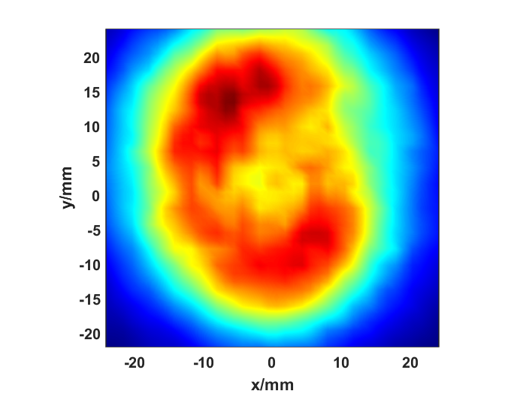

Figure 5. Donut-shaped beam profile of the FIR laser measured 1 meter from the output window.

1. **Alignment process and beam pattern quality improvement**

(a). CO2 laser alignment

The system alignment is setup as shown in Fig. 6. Since the CO₂ laser is invisible to the human eye, a HeNe laser is used to align the CO₂ laser with the FIR laser system. The HeNe laser is positioned as far as practical from the output of the FIR laser system, approximately 4.8 m in this case. To allow the visible laser to pass through FIR laser system unobstructed, the metallic mesh, front mirror, rear mirror and lens are temporarily removed. Alignment guides are temporarily placed in the input and output ports to aid in beam alignment. The guides were made from black Delrin, to achieve a snug fit in the bore with a pinhole drilled in the center. The HeNe laser is finely adjusted to ensure that the beam passes through the center of both the input and output windows.

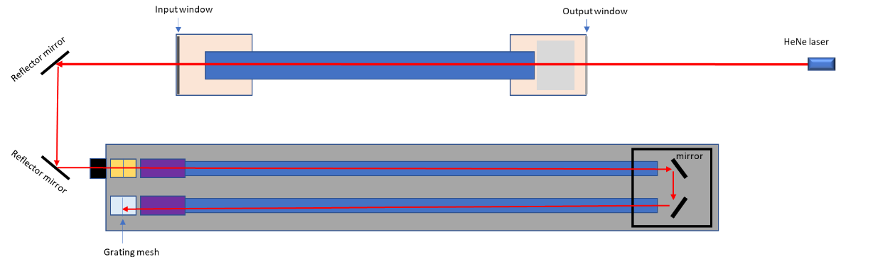

Figure 6. CO2 laser alignment setup

The visible laser beam is then reflected into the CO₂ laser output window using two reflector mirrors, as shown in Fig. 6. The second mirror should be temporarily rotated back and forth to fine-tune the beam height for proper entry into the CO₂ laser and adjusted to ensure it is parallel to the optical table. If the beam does not pass through the center of the CO₂ laser output window, the CO₂ laser system should be repositioned to align the window center with the visible laser. Another Delrin guide is used in the end of the output coupler to determine when the beam is centered. If the footprint is not centered on the grating, the CO₂ laser system position should be carefully adjusted to ensure the laser is hitting the center of the grating. This can be a tedious process, as it requires vertical axis rotation, translation, and elevation adjustment of the CO₂ laser. A laser level can be used in conjunction with the HeNe to adjust the elevation of the CO₂ laser. With the lights in the lab off, it is possible to observe reflections of the HeNe laser on the CO₂ laser waveguide, when viewing the reflection from the correct angle. The laser can then be pivoted and recentered, using the output coupler target, to move the reflection down the waveguide until it exits the mirror box and appears on the second waveguide. This process is continued until the faint image of the HeNe can be observed on the grating. With the FIR system and the CO₂ system aligned using a HeNe laser, the CO₂ laser is co-axial with the FIR waveguide tube. This alignment maximizes the CO₂ laser's reflections within the FIR waveguide tube, thereby enhancing absorption and energy transfer to the formic acid gas.

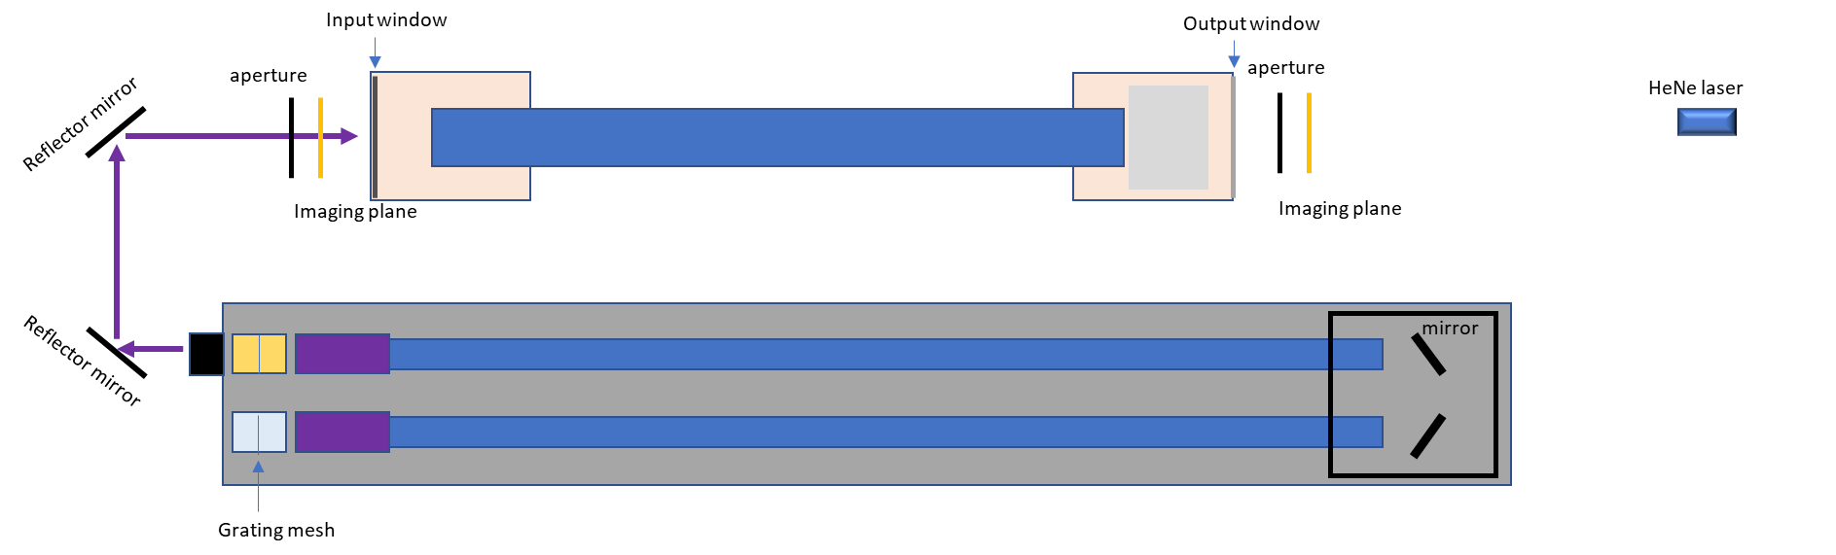

Figure 7. CO2 laser alignment benchmark

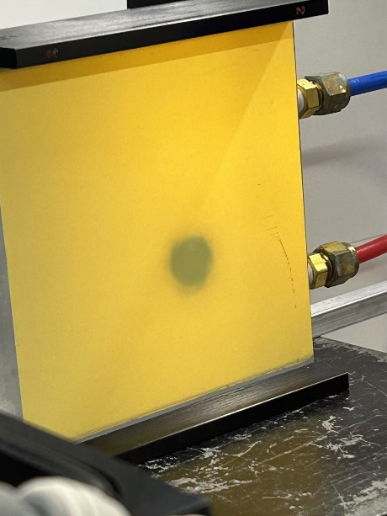

Figure 8. The imaging of the CO2 laser beam profile

As shown in Fig. 7, To verify the alignment of the CO₂ laser with the FIR system, two adjustable apertures are positioned in front of the input window and behind the output window of the FIR laser system. The center of each aperture is aligned with the axis of the HeNe laser path. An imaging plate is used to illustrate the CO₂ beam profile as shown in Fig.8.

The alignment procedure is as follows: first, the apertures are fully opened, and the CO₂ laser is turned on to check whether the beam profile aligns with the HeNe laser optical path at both positions. The method involves gradually reducing the aperture size and examining the clipped beam profile. If the beam profile is symmetrically clipped, the CO₂ beam is aligned with the main optical axis. If asymmetry is observed, the beam is shifted toward the side where more clipping occurs. By checking the beam position at both locations and making slight adjustments to the mirror angle, the CO₂ beam can be aligned with the axis of the visible laser.

(b). FIR laser alignment

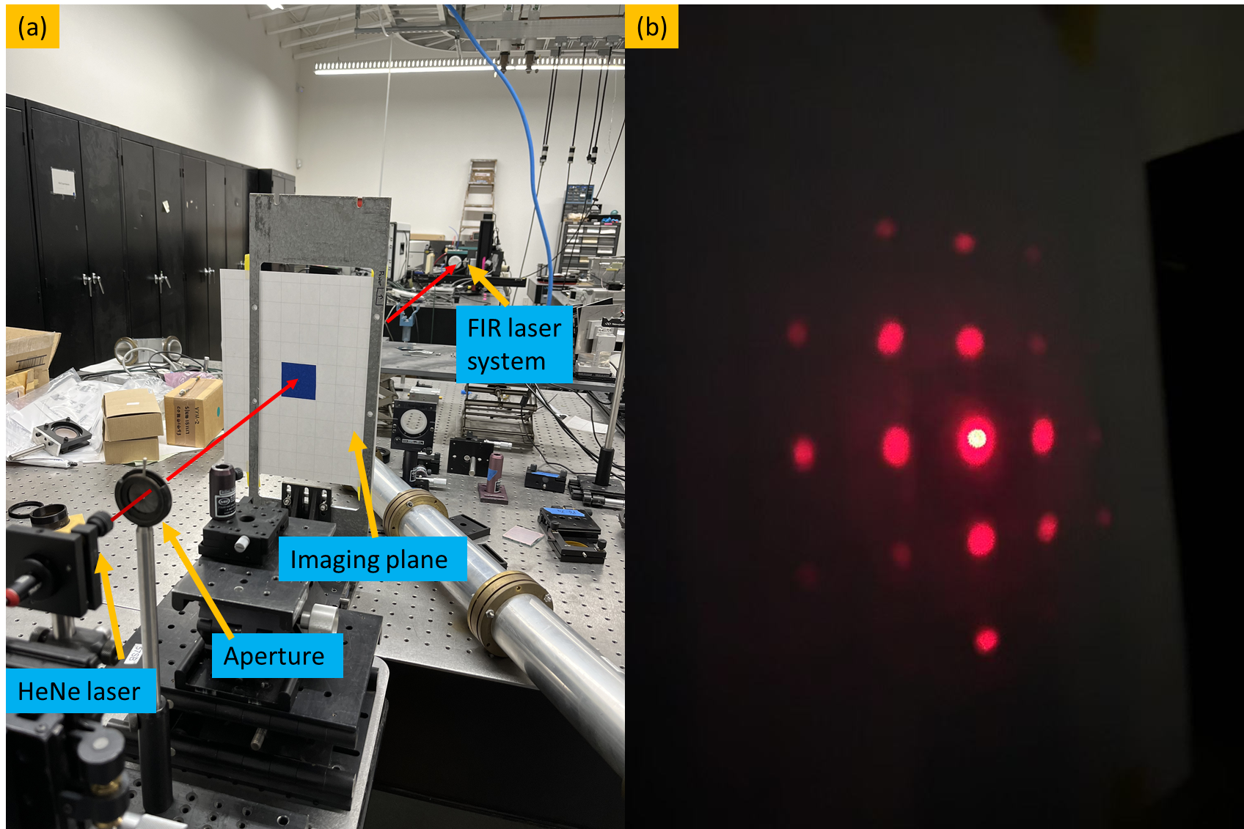

Figure 9. (a) FIR laser system alignment setup. (b) diffraction pattern on imaging plane from the metallic mesh

The mirror inside the FIR laser system is aligned based on the reflection of the HeNe laser. As shown in Fig. 9 (a), an imaging plane with a small aperture is positioned in front of the HeNe laser to allow the reference beam to pass through. The distance between the imaging plane and the output window is approximately 3.5 m, ensuring high-precision angular alignment in 0.1 degree.

The alignment procedure begins with the installation of the rear mirror, which contains a central aperture to transmit the CO₂ laser. The rear mirror is carefully positioned so that its center coincides with the HeNe laser beam. As the diameter of the HeNe laser beam is slightly larger than that of the aperture, Fraunhofer diffraction is observed on the imaging plane. By adjusting the rear mirror to align the central diffraction pattern with the aperture on the imaging plane, it can be ensured that the rear mirror is perpendicular to the optical axis.

Similarly, the front mirror reflects the HeNe laser, and its alignment is optimized by adjusting its angle until the reflected beam precisely overlaps with the central aperture on the imaging plane. For the metallic mesh, alignment is achieved by modifying its angle until the zero-order diffraction pattern coincides with the central aperture on the imaging plane, as shown in Fig. 9 (b).

(c) Beam profile improvement after alignment

The beam profile is measured using a self-developed auto-scanning stage system. This system includes a power detector with a window diameter of approximately 5 mm and a three-stepper motor stage that drives the optical stage in the X, Y, and Z directions. As shown in Fig. 10, two power monitors are used—one for power measurement and the other for reference power measurement at a fixed position. The real beam profile would be demonstrated as the distribution of Pscan/Pref, where the Pscan refers to the scanning channel power at each point while the Pref refers to the power on reference channel at each point. This approach helps compensate for power fluctuations during the measurement. A power detector with a chopper, positioned in front of the FIR window at approximately 300 mm, measures a 20 mm × 20 mm range in the X-Y direction with a step size of 2 mm.

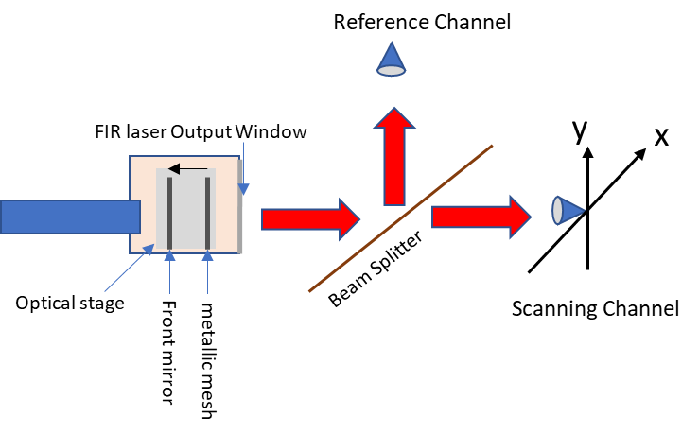

Figure 10. Beam profile measurement setup

The beam profiles before and after alignment are shown in Fig. 11. As seen in the figure, before alignment, the FIR laser contains higher-order modes within the cavity, resulting in a beam profile that deviates significantly from a Gaussian shape. After alignment, the beam profile is dominated by the fundamental HE₁₁ mode, yielding a nearly perfect Gaussian distribution. The total intensity was measured using a Scientech Astral AI310 Power Monitor, with a detected power about 30 mW.

Beside this, the beam profile at different distance from laser window to the scanning plane also measured as shown in Fig. 12. It given that both X direction and Y direction are shown have same beam waist radius about 10.8 mm located at the window within 0.3 mm as zX0 = 0.14 mm and zY0 = -0.28 mm.

Without external influences (e.g., human disturbance or mechanical shocks), the system typically maintains alignment for several months. However, periodic checks (e.g., every few weeks) are still recommended to account for gradual thermal drifts or subtle mechanical shifts.

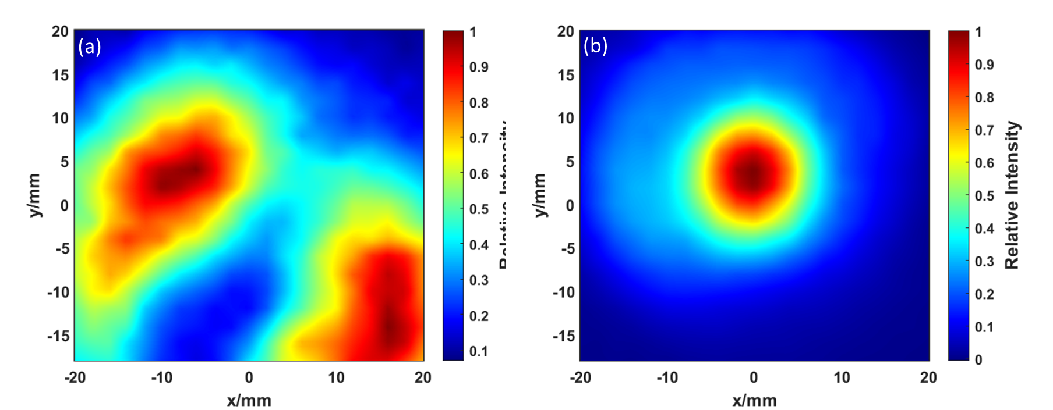

Figure 11. Beam profile of the FIR laser measured at a distance of 300 mm from the laser window to the scanning plane: (a) before alignment, and (b) after proper alignment.

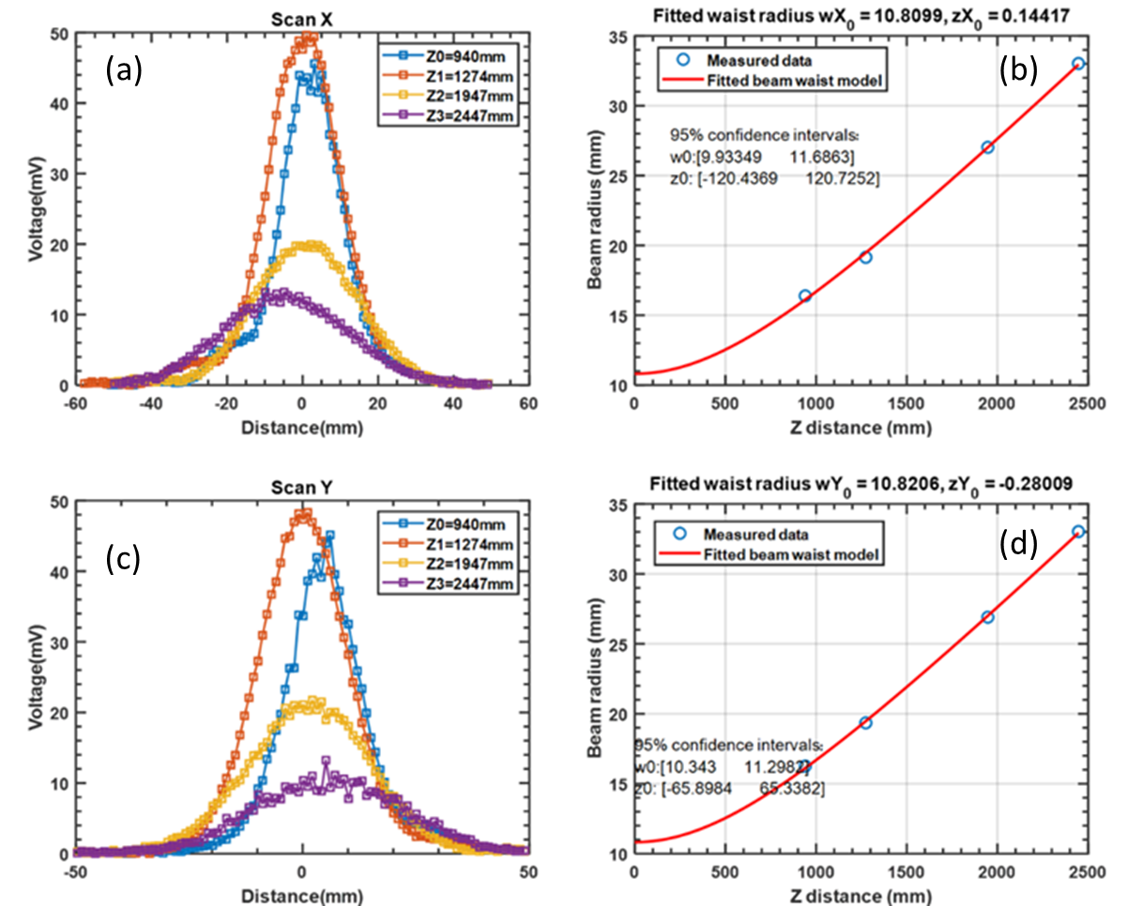

Figure 12. (a) and (c) Scanned beam profiles at four different distances along the X-axis and Y-axis, with the zero-position set at the center of the laser beam. (b) and (d) Gaussian fits along the Z-axis to determine the beam waist radius and waist position for the X-axis and Y-axis, respectively. Here Zi refers to the distance from the laser window to the scanning plane.

**Section IV: Beam power stabilization**

1. **Beam power decreasing with nature operation (no feedback control)**

Since the beam intensity is highly sensitive to the cavity length, maximum output power can only be achieved under resonant conditions. Therefore, cavity adjustment is necessary during operation. Even if the FIR laser cavity is initially set at the optimal resonant condition, the distance between the rear mirror and the metallic mesh will shift due to thermal expansion during operation, resulting in a decrease in FIR laser power. As shown in Fig. 13, the FIR laser power will decrease to 1/3 of original power in 3 minutes.

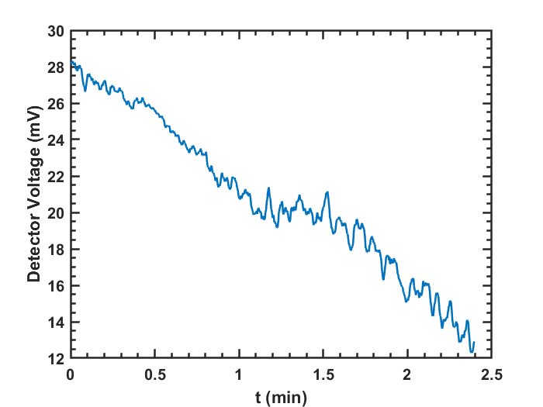

Figure 13. FIR power evolution without feedback control

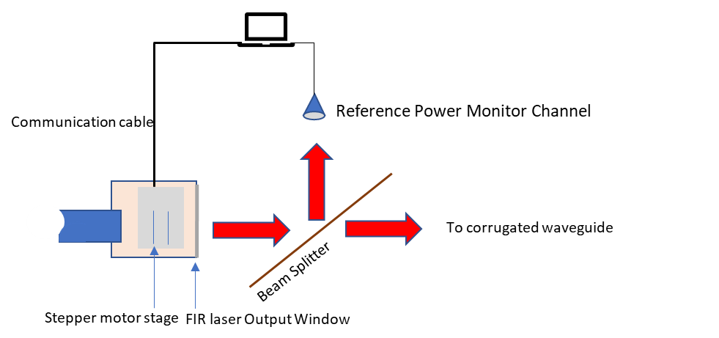

Figure 14. FIR laser cavity adjustment setup

1. **Key parameters (beam power): cavity length, gas pressure**

To add feedback control of the cavity with the output power, the cavity adjustment setup as shown in Fig. 14 is established for optimizing beam power. A beam splitter with a 10:1 intensity ratio is used, where the reference channel utilizes the lower-intensity portion to monitor power variations, while the main power is used for diagnostics. A computer analyzes the power evolution and controls the stepper motor stage, which adjusts the cavity length accordingly.

1. **Intensity instability caused by thermal expansion**

As shown in Fig. 15, the FIR laser intensity varies with the scanning of the cavity length. The peak-to-peak distance is approximately 216 µm, which is about half of the wavelength (432.6 µm). Furthermore, when zooming in on a single peak structure, small fluctuations are observed with a periodicity close to a quarter of the CO₂ laser wavelength (9.27 µm).

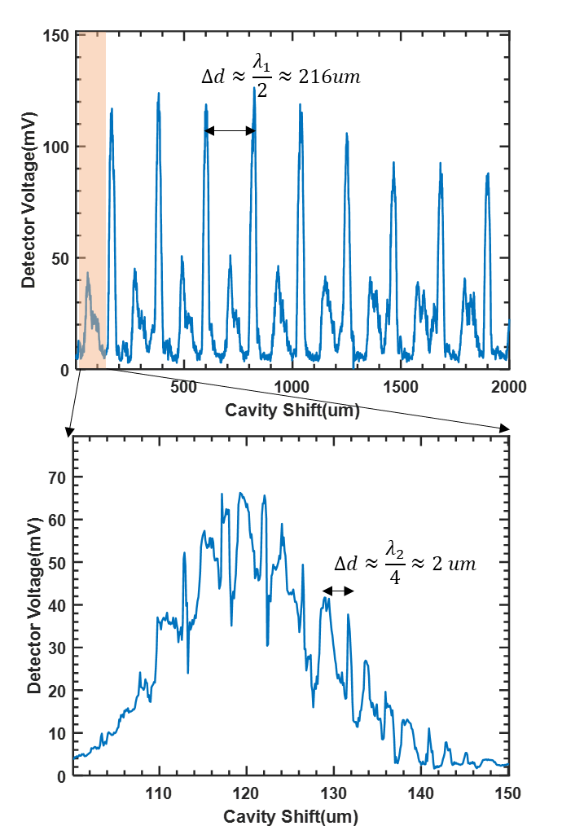

Figure 15. FIR output intensity with cavity shift measured under Formic acid gas pressure around 150 mTorr

The difference between the FIR and CO₂ laser resonance structures originates from their distinct boundary conditions. For the FIR laser, the resonant space is defined between the metallic mesh and the rear mirror, both of which can be approximated as perfect electric conductors. This results in the boundary condition ${k_{1}d}_{1}=nπ$, leading to a resonance spacing of $Δd_{1}=\frac{π}{k}=\frac{λ_{1}}{2}$, where k1​ is the wavevector of the FIR laser, n is an integer number, $λ_{1}$ represents the FIR wavelength and d1 is the distance between the boundaries.

In contrast, for the CO₂ laser, the resonant space is between the front and rear mirrors, with the front mirror being a dielectric wafer. This modifies the resonance condition to $2{k_{2}d}_{2}+ϕ=nπ$, where d2 is the resonant cavity length, k2 is the wavevector of the CO₂ laser, and $ϕ$ accounts for the phase shift upon reflection from the front mirror surface. Consequently, the resonance spacing is given by $Δd_{2}=\frac{λ_{2}}{4}$, where $λ_{2}$ represents the CO2 laser wavelength, which agrees well with the experimental results.

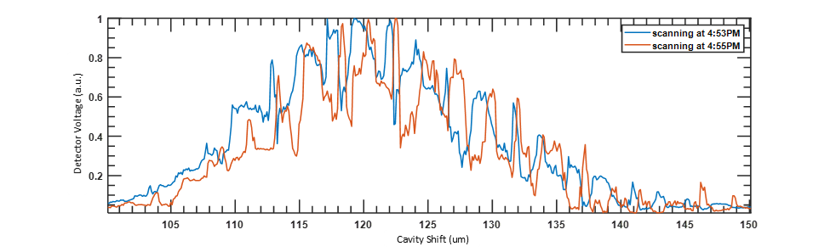

Figure 16. FIR intensity structure with cavity shift at two different times.

As a result, the intensity of the FIR power depends on both the FIR wave resonant condition and the CO₂ laser resonant condition. As shown in Fig. 15, due to the thermal expansion, the FIR intensity profile gradually shifts to the right over time, in the direction corresponding to the cavity’s thermal expansion. If the cavity position remains fixed, the intensity drops by approximately 40% within the first 2 minutes — corresponding to about 1 μm of cavity expansion — before the system begins to stabilize. Full thermal stability typically requires about 2 hours to achieve. These fluctuations introduce uncertainty in determining whether observed variations arise from plasma dynamics or from the laser system itself, thereby reducing the accuracy of high-k spectrum evolution diagnostics.

1. **Intensity instability with HCOOH gas pressure**

Since the strong fluctuation is caused by CO₂ laser resonance, it is important to mitigate this effect. Fortunately, it is possible to reduce the fluctuation by increasing the HCOOH gas pressure. Higher HCOOH pressure enhances CO₂ laser absorption, thereby reducing the resonance effect and resulting in a smoother FIR intensity profile. As shown in Fig. 17, once the pressure exceeds 190 mTorr, the fluctuation becomes significantly smaller. However, as the pressure increases, the maximum intensity also decreases. To balance intensity and fluctuation, we choose a pressure around 221 mTorr as the optimal value.

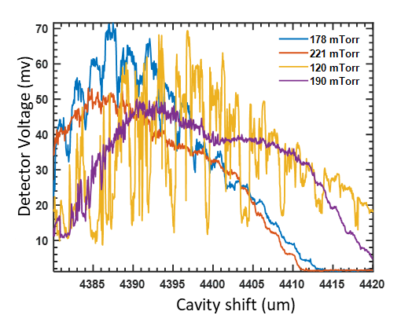

Figure 17. Scanning Cavity under different gas pressure

1. **Beam power performance with feedback control module**

Since the main resonance structure of the FIR laser will shifts to the right due to thermal expansion, leading to an intensity drop if the cavity remains stationary. To address this, a feedback control system is implemented for automatic cavity optimization. The system continuously monitors the power of FIR, and once the intensity drops to 80% of its original value, it drives the stepper motor to adjust the position of the mesh and front mirror, shifting the cavity to the right to find the optimal position. Controlled by LabVIEW, the system integrates the power monitor, a Thorlabs stepper motor, and a host computer. It operates automatically to maintain the cavity at its optimal position, with each adjustment process taking approximately 10 seconds. With the feedback control system, the output power can be maintained over a long time period, as shown in Fig. 18, where the downward peaks correspond to the auto-adjustment process.

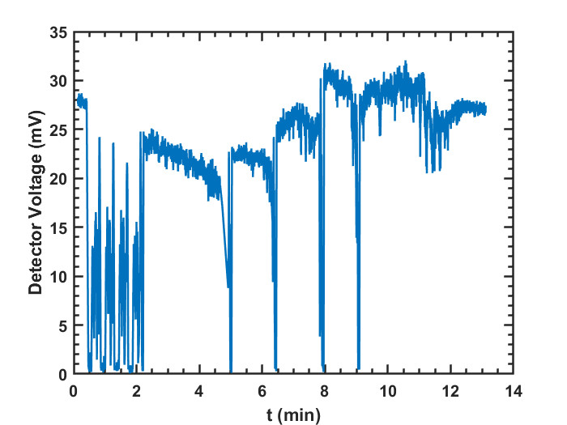

Figure 18. FIR laser intensity evolution with feedback control.

The regular adjustment initially occurs approximately every 2 minutes. After about 1 hour, the system reaches thermal stability, and the adjustment interval increases to around 20 minutes.

**V: Summary**

The high-k scattering system requires a FIR laser with a Gaussian beam profile and stable power output. To meet this requirement, a compact and well-designed alignment method is presented in this paper. This method includes alignment using a visible HeNe laser, mirror alignment based on diffraction patterns, and checking the CO₂ laser beam position at the imaging plane. Through cavity feedback control and optimization of the formic acid gas pressure, the system can achieve a high-quality Gaussian beam profile with a beam waist radius of approximately 10.8 mm located at the FIR laser output window, an intensity of about 30 mW, and stable long-term power output. This alignment approach is not only applicable to the high-k system but can also be used for the TIReTIP laser system and other pump laser adjustments.